Restaurant Reservation Web Application User Manual

CSIS 3280 Group Project - RestnReserveGroup

Rafael Olivaires 300300098

Rafael Machado 300268641

Jonah Roesler 300279311

Due: 2019-04-03

When you first visit the site it will look like this

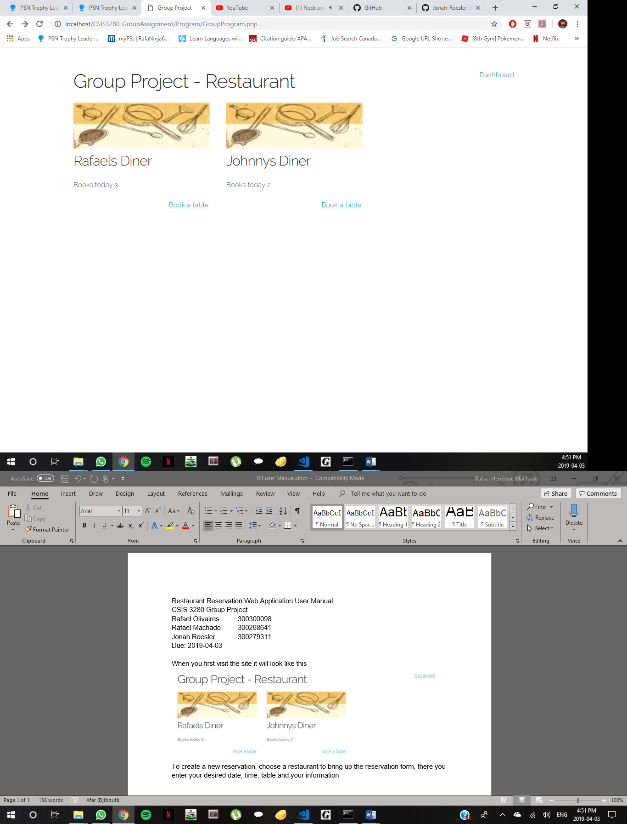

To create a new reservation, choose a restaurant to bring up the reservation form, there you enter your desired date, time, table and your information

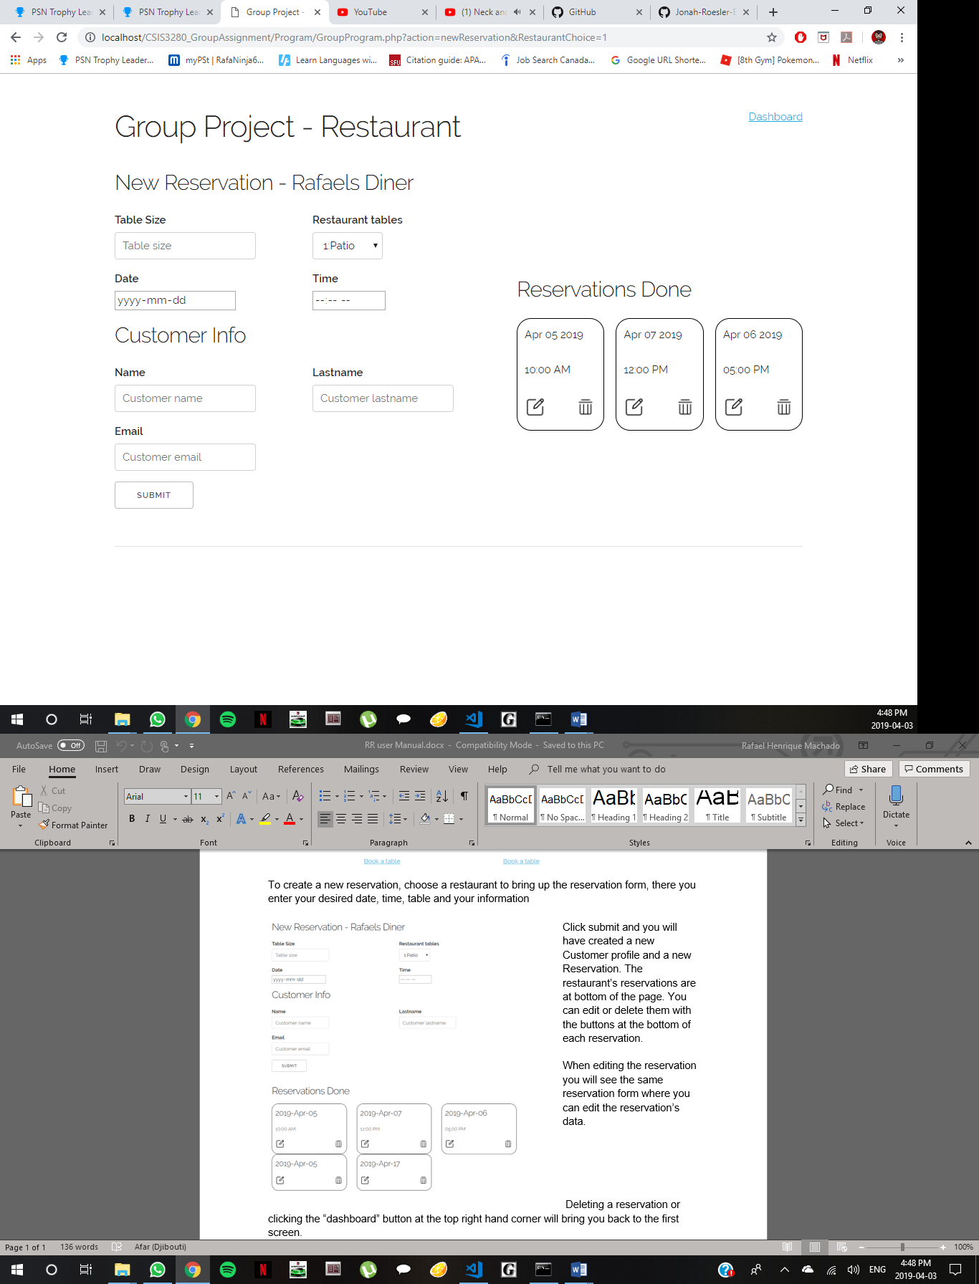Click submit and you will have created a new Customer profile and a new Reservation. The restaurant’s reservations are at bottom of the page. You can edit or delete them with the buttons at the bottom of each reservation.

When editing the reservation you will see the same reservation form where you can edit the reservation’s data.

Deleting a reservation or clicking the “dashboard” button at the top right hand corner will bring you back to the first screen.